CHALLENGE:

I started with a menu tab. There are four buttons: Easy, Moderate, Hard, and Clear. By selecting any of these, the requested information will be posted to tabs containing data. 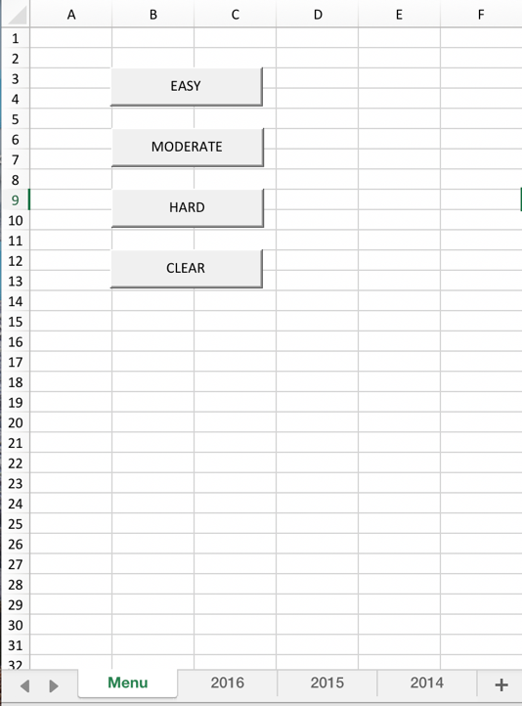

After selecting the “level,” to clear the data, hit the clear button. The requested information will be cleared from the tabs. It takes time to run.

Below are some of the screenshots collected for each assignment type (EASY, MODERATE, AND HARD). I have included the raw pngs in the accompanying file. All screenshots are from the 2016 tab.

EASY:

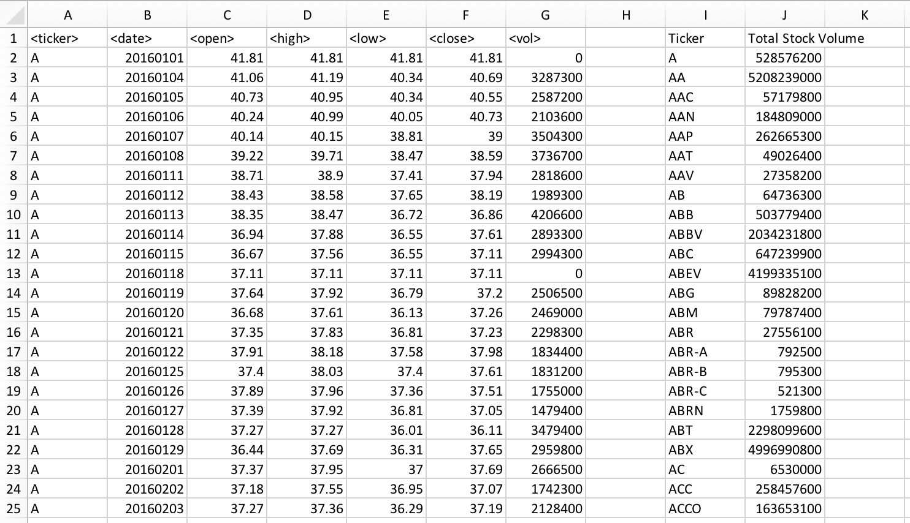

MODERATE:.

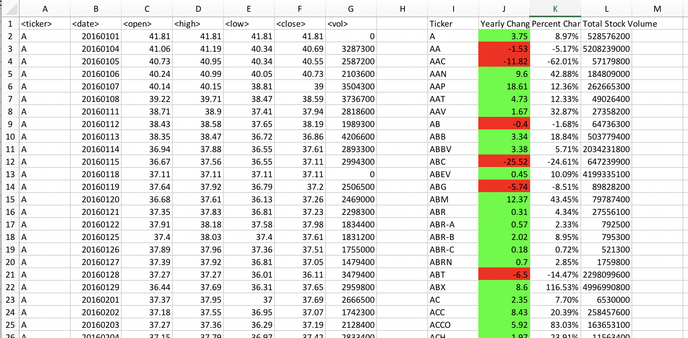

HARD: